W-20
YEAR 10 SCIENCE (GENERAL)
BIOLOGICAL SCIENCES
TEST - GENETICS

NAME: MARK: $\frac{}{\text{57}}$

SECTION A: MULTIPLE CHOICE

Select the best answer for each question below. Write your selection in the box to the right.

MULTIPLE CHOICE ANSWERS
1
2
3
4
5
6
7
8
9
10
11
12
13
14
15
16
1. The chemical compound that contains the coded instructions for the way that cells develop is:

(a) an amino acid.
(b) DNA.
(c) glucose.
(d) HCl.

2. In eukaryotes, DNA is produced in the:

(a) cell membrane.
(b) endoplasmic reticulum.
(c) nucleus.
(d) cytoplasm.

3. When cells are about to divide, lengths of DNA shorten and coil to form:

(a) chromosomes.
(b) genes.
(c) messenger RNA.
(d) zygotes.

4. A sequence of three nucleotides in a triplet provides the code for a particular amino acid. Combinations of three of the letters A, T, C, G and U are used to represent triplets in nucleic acids.

e.g. CGA, TGA, UGG.

Each letter represents:

(a) each of the different three parts of the nucleotide - one a sugar, one a phosphate and one a nitrogenous base.
(b) each of the different nitrogenous bases that can be found in a nucleotide.
(c) each of the different phosphates that can be found in a nucleotide.
(d) each of the different types of sugars that can be found in a nucleotide.

5. The process of cell division that produces the gametes in the sex organs is:

(a) cloning.
(b) fertilisation.
(c) meiosis.
(d) mitosis.

6. Which one of the following statements does not apply to mitosis?

(a) It occurs in asexually reproducing organisms.
(b) There is no variation in the new cells of the offspring.
(c) It is used in tissue culture for cloning plants.
(d) The process is completed with two cell divisions.

7. When a pure-bred black (BB) domestic fowl is crossed with a pure-bred white (bb) domestic fowl, the hybrid (Bb) offspring is speckled, or splashed white. When a pure-bred black domestic fowl is crossed with a speckled domestic fowl, the chance that the offspring will be speckled is:

(a) 0%.
(b) 25%.
(c) 50%.
(d) 75%.
(e) 100%.

8. If a woman has already given birth to four boys, the chance that she will have a girl next time is:

(a) zero.
(b) one in five.
(c) one in four.
(d) one in two.
(e) 100%.

9. Which one of the following statements about mutations is not correct?

(a) Mutations can be caused by radiation.
(b) A mutation is a change in a gene or chromosome.
(c) All mutations are harmful.
(d) Mutations can occur as DNA is being copied.
(e) Mutations can occur by pure chance.

10. When red-flowered snapdragons are crossed with white-flowered snapdragons, some of the offspring have pink flowers. This is an example of:

(a) cloning.
(b) incomplete dominance.
(c) karyotyping.
(d) mutation.

11. Variation within a species can occur by:

(a) mutation.
(b) pure chance.
(c) the production of gametes.
(d) fertilisation of ova by sperm.
(e) all of the above.

12. If a sperm with an X chromosome fertilises an egg, what sex will the baby be?

(a) It is difficult to tell from the information given.
(b) It has a 50% chance of being male or female.
(c) Female.
(d) Male.
13. Three different cells contain one of each of the following sets of
genes.

AA Aa aa

Which set of genes represents homozygous (pure-breeding) strains?

(a) AA
(b) Aa
(c) aa
(d) AA and aa.

14. Tongue rolling is due to the dominant gene R and the inability to roll your tongue is due to the
recessive gene r. Which of the following pairs of parents could produce a non-tongue roller
(rr)? (Hint: You may need to do some Punnet squares to work it out.)

(a) RR and RR
(b) RR and Rr
(c) RR and rr
(d) Rr and Rr

15. Major differences between males and females are determined by pairs of sex chromosomes.
For example, Jane is a girl and Jim is a boy, because in each cell nucleus:

(a) Jane has two X chromosomes; Jim has two Y chromosomes.
(b) Jane has two Y chromosomes; Jim has two X chromosomes.
(c) Jane has an X and Y chromosome; Jim has two X chromosomes.
(d) Jane has two X chromosomes, Jim has an X and Y chromosome.

16. The following pedigree shows the occurrence of colour blindness in three generations of a
family.

From the above family tree, it can be concluded:

(a) B1 has normal vision.
(b) A2 has colour blindness.
(c) C3 is colour blind.
(d) C1 has normal vision.

SECTION B: SHORT ANSWER

1. Label the parts of the cell as shown in the diagram below. (6 marks)

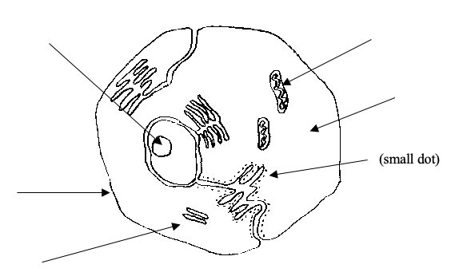

2. Complete the following table, giving the name of the part of the cell (animal or plant) responsible for the process. (5 marks)

Role or Function in The Cell | Name of Part
Protects the cell and lets substances in and out.
Produce spindles for chromosome separation in cell division.
Produces energy for the cell.
Controls the functions within the cell.
Produces proteins for the cell.

3. (a) Give a brief description of the DNA molecule. (1 mark)

(b) Name the 4 bases in a DNA molecule. (2 marks)

(c) Name the base pairs found in DNA. (2 marks)

(d) Draw the adjoining strand of DNA for the following. (1 mark)

- G - T - T - A - C - A - G - T

4. An organism has 3 chromosomes in its normal body cells. Draw a series of simple diagrams showing the stages involved in mitosis. Name each stage and state what is happening in each. (5 marks)

Stage Name | Drawing | Description
6. In the table below, choose the correct statement for each word given. Write the letter of the correct statement next to the word.
(4)

WORD | CORRECT  LETTER | STATEMENT
hybrid |  | A - how an organism looks due to its genes.
gamete |  | B - hides the other gene in a pair (e.g. T).
dominant |  | C - see a new characteristic in an organism.
incomplete dominance |  | D - same genes in a pair (e.g. TT, tt).
genotype |  | E - gene that is hidden by another gene (e.g. t).
pure-bred |  | F - the genes for a particular characteristic.
recessive |  | G - sex cell of an organism
phenotype |  | H - different genes in a pair (e.g. Tt)

7. In pea plants, the allele for tall height (T) is dominant over the allele for short height (t).

A homozygous (pure-breeding) tall plant is crossed with a heterozygous (hybrid) tall plant.
List the possible genotypes and phenotypes of the offspring and show the probability
(percentages) for each offspring. (Set your working out clearly.) (4 marks)

8. (a) In budgerigars, blue colour (BB) and yellow colour (YY) show incomplete dominance,
producing a blended colour of green (BY).

A male green budgerigar is crossed with a yellow female. Show the genotype and
phenotype of the possible offspring. (Set your working out clearly.) (4 marks)

(b) Explain how incomplete dominance is different to co-dominance. (2 marks)

5. The pedigree below shows the occurrence of myopia (short-sightedness) in three generations of a family.

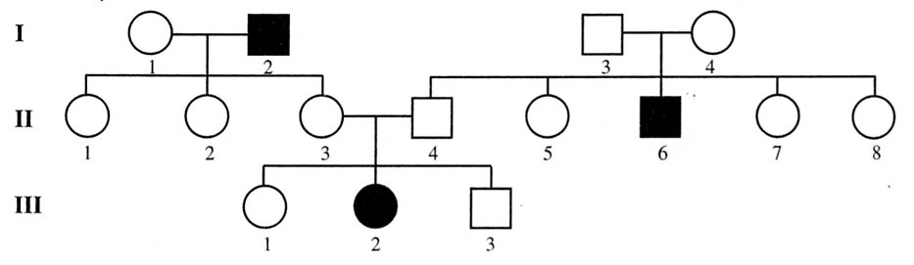

(a) Determine if the condition is dominant or recessive. Explain your answer.
(You may like to circle the part of the pedigree you are considering in your answer.) (2 marks)

(b) Determine the genotypes of the individuals in the pedigree. (Remember to work from
the bottom up.)

Write the genotypes for the following individuals. (3 marks)

Generation III Individual 1

2

Generation II Individual 3

4

Generation I Individual 1

2

